

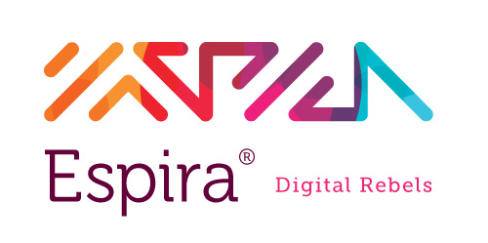

**Host Communities Project–**

**Website Development Proposal**

November 17th, 2013



**Espira**

**Tel.** +962 6 4631310,   **Fax** +962 6 4631319

P.O. Box 831382 Amman 11183, Jordan  
[**www.espira.jo**](http://www.espira.jo)



**Letter of Introduction**

Dear Mr.Mohammad,

We would like to thank you for giving us the opportunity to submit a proposal for the design and development of the **Host Communities Project** website. This proposal confirms that we are ready, willing and able to grow our partnership with **Host Communities Project**.

As per our last meeting we have enclosed our revised technical and businessproposal, should you require any further information do not hesitate to contact us. We look forward to a long and mutually beneficial business relationship.

Once again, thank you for this opportunity and we look forward to working with you in the near future.

Yours Sincerely,

YassminShahin

Managing Director



Tel:  +962 6 4631310 ext. 121

Fax: +962 6 4631319

P.O. Box 831382 Amman 11183 Jordan

E-mail: [y.shahin@insightgroup.me](mailto:y.shahin@insightgroup.me)

[http://www.espira.jo](http://www.insight.com.jo/)

**About Us**

**Espira** is a dynamic digital marketing agency that breaks the rules and norms of traditional marketing and creates originality and innovation through our signature rebellious character in Web Solutions, Digital Marketing and Interactive Multimedia.

We believe in creating relevant, engaging, and strategically sound ideas/solutions for our clients through breakthrough thinking and problem solving.

Our mission is to help you construct an on-line image that supports your organizations objectives. Our mission is about fulfilling clients’ needs and desires by delivering the very best solutions.

## **Our Key Competencies**

* *Experience and Expertise*

We have successfully completed numerous projects of different sizes and complexities in various business and technology domains.

* *Commitment to Quality*

#### We are attached to a definite set of quality control measures and under no circumstances would compromise that quality.

* *Fast Delivery*

We are dedicated to complete our projects in the given time frame and can assure you that once you work with us, it will be our main concern to deliver your solution on the defined time.

All members of our team come with many years of experience working in global advertising agencies catering to numerous Fortune 100 companies. Through this background, our team has been able to deploy hundreds of websites and online campaigns.**Some of our Clients**

**Work Samples**



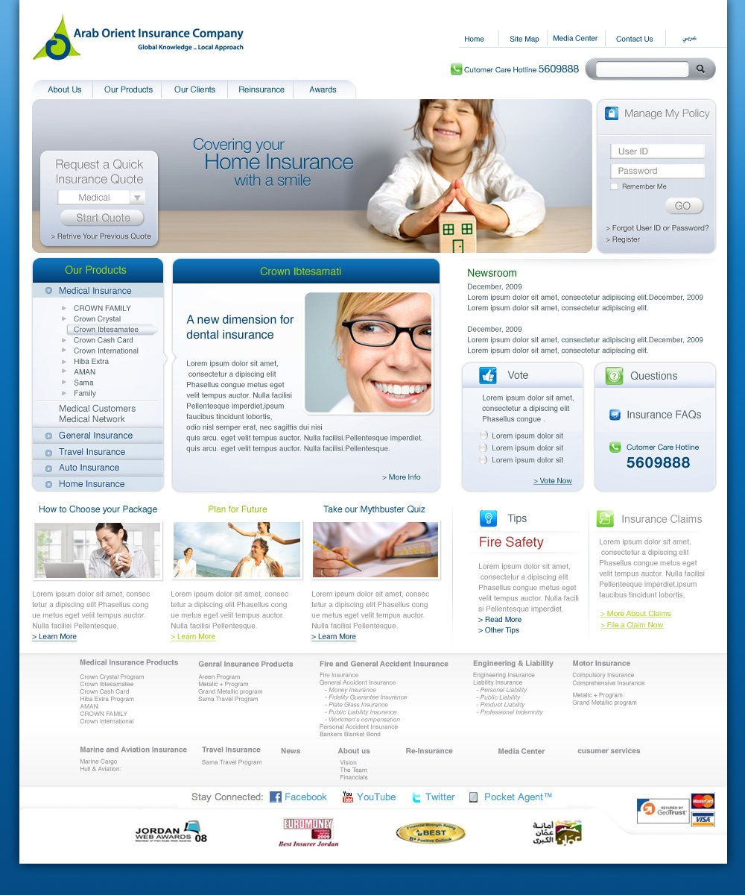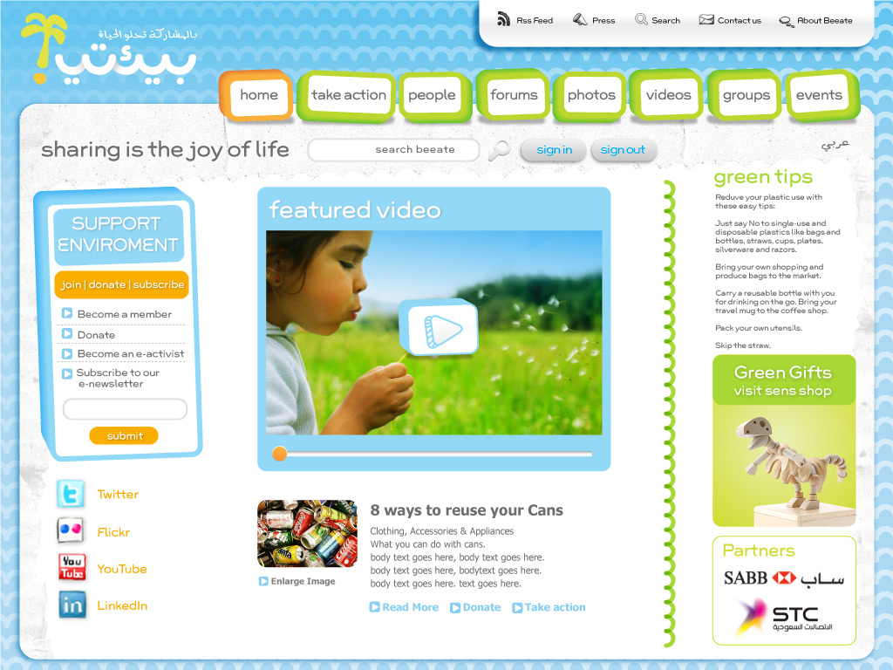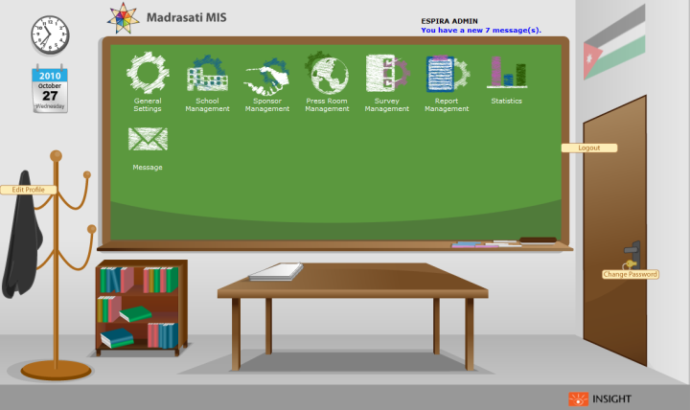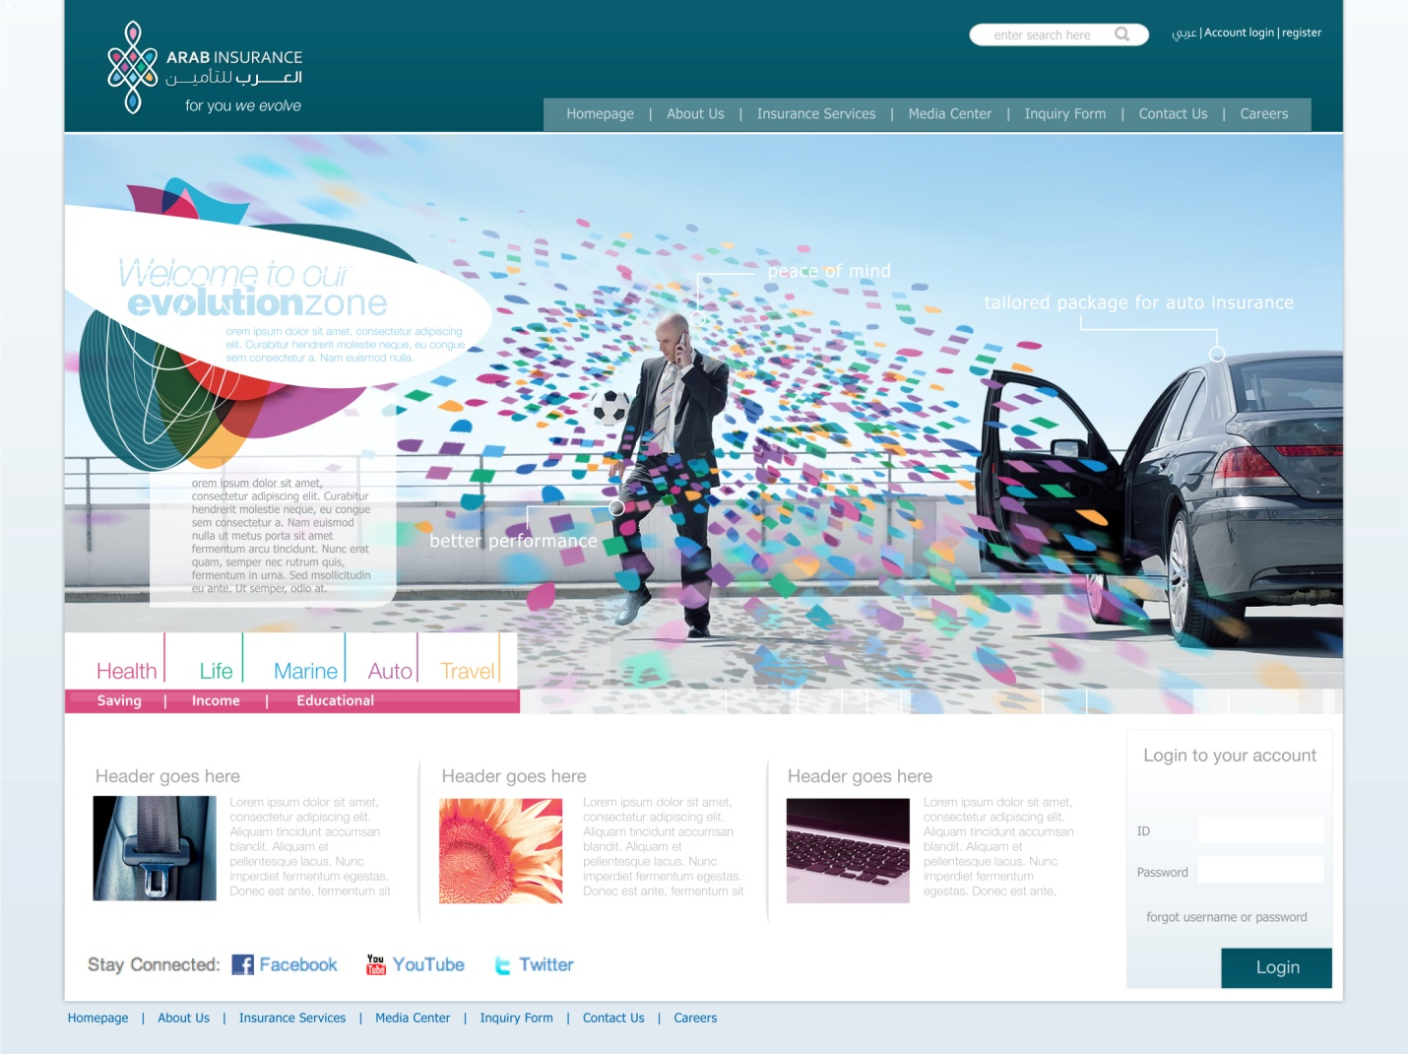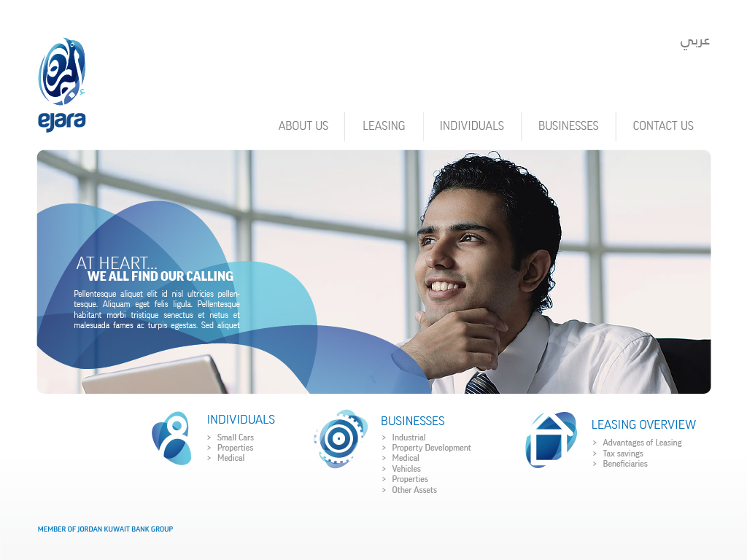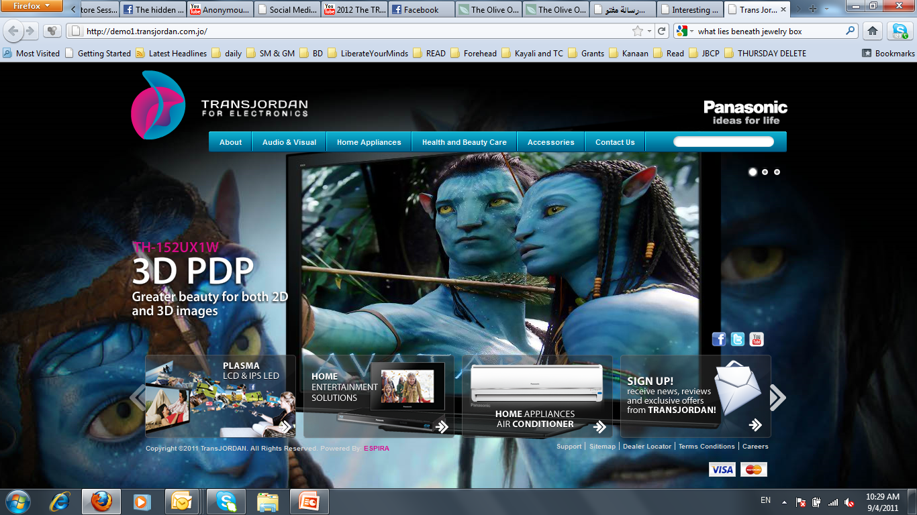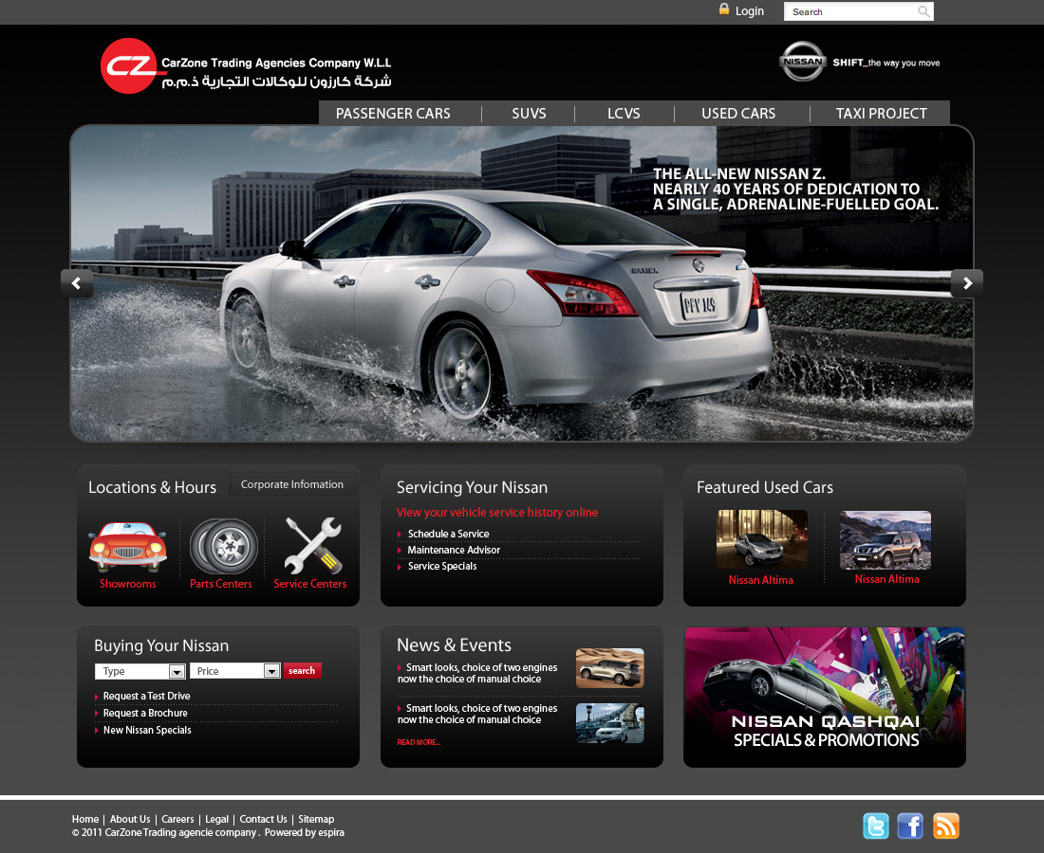

# **Proposed Site: Scope of Work**

The new **Host Communities Project** website should provide a clear idea of **Host Communities Project’s** business focus and expertise. The website will be deployed in 2 different languages: initially starting with English, followed Arabic. The website will be globally advertised under your domain.

This proposal serves to outline the requirements for the new **Host Communities Project** website.

The website will be developed in English at first and will serve the following key objectives:

1. Provide clear information about **Host Communities Project,** its objectives, mission and vision, project activities, news and events, and achievements.
2. Provide information about **Host Communities Project’s** various services & projects.
3. Provide potential visitors with multiple channels of communication to get in touch with **Host Communities Project** (Email, Telephone, Postal Mail, and Social Media).
4. Maintain and enforce a professional look and feel for **Host Communities Project**.
5. Be designed in a modular fashion to allow for expansion in the future.
6. Provide clearer usability& experience for visitors.

**Proposed Site Structure**

The below table provides the proposed **Host Communities Project** website structure based on the details sent with the proposal request along with our recommendations.

The proposed structure is built on a strategy to categorize information based on user-accessibility, while maintaining the manageable number of primary links so as not to confuse site visitors and allow for future expansion.

It is envisioned that site visitors will not exceed 3 clicks to get from one page of the site to another. A 3 tier category-based navigation will be developed to divide the available information into sections to help visitors quickly identify the information they are looking for by presenting the links in a visually structured manner. The recommended categories also provide room for growth in all navigation tiers to help minimize excessive redevelopment in the future.

It should be noted that the below structure may be re-ordered as production of the website begins as some pages may prove to be better suited to a different category than initially proposed. Any such changes would be recommended to **Host Communities Project** and would require approval prior to being implemented.

|  |  |  |  |
| --- | --- | --- | --- |
| **Tier 1** | **Tier 2** | **Tier 3** | **Details** |
| Homepage |  |  | Homepage featuring the various elements of the website. In addition to featured news & stories rotators |
| About |  |  |  |
|  | About Host Communities Project |  | An Informative page showing general brief about Host Communities Project & its objectives |
|  | Vision & Mission |  | An Informative page contains Host Communities Project vision & mission |
|  | Organizational structure & Members |  | An Informative page contains the organizational structure of Host Communities Project & listing of the key members |
| Programme |  |  | An Informative page showing full details about Host Communities Programme |
| Areas of Interventions |  |  | An Informative page contains the focus areas of Host Communities Programme |
| Media Center |  |  |  |
|  | Resources |  | List of public documents (any file format) with description, tags & keywords, with the ability to view & download these files |
|  | Publications & Reports |  | List of the latest releases, publications, surveys & statistics of Host Communities Project |
|  | Photo & Video Gallery |  | Contains a gallery of images & videos for Host Communities Project |
| News Center |  |  | Contains the latest news of Host Communities Project Company |
| Our Stories |  |  | List of Host Communities Project’s success stories along with the details about each story |
| Events Calendar |  |  | This section will allow you to add events to be viewable by your website visitors. |
| Contact Us & Location Map |  |  | Contains enquiry form & all contact info along with directions map for your physical location |
| Careers |  |  | Contains a form where users can apply for a vacancy & submit their CVs |
| **Secondary Links** | | | |
| Sitemap |  |  | Sitemap page (the main |
| Privacy Policy |  |  | Privacy Policy page |

***\*The site structure above can be amended according to Host Communities Project continuous feedback throughout building the website. More pages can be added without extra charge.***

## ***\*All pages of the website may include sharing tools for the Host Communities Project website to be easily shared by visitors to social networking sites such as Facebook, Google+, Twitter and others if desired.***

## **Site Creative Strategy**

The objective of the creative strategy is to represent **Host Communities Project** as a reliable and trusted source in its field. This objective will be achieved through relevant imagery and content that showcases **Host Communities Project’s** area of expertise.

###### Imagery

The imagery selected for the website will be based on available images from **Host Communities Project** and/or online image sourcing.

**Design Development**

The design of Host Communities Project website has been already given with the proposal request. However, there will be some minor modifications on the current design that will improve the user experience and usability.

**Content Management System (CMS)**

Your System will be a fully dynamic CMS. You can create, edit and delete content all around the website. The CMS provided with a rich Text editor to ease the process. You can add links, images and style your text in a very easy way.

The CMS let you control the menus and navigation panels in the website. Delete menu items, edit menu links and even add new pages and link them to a new menu item; this way you will have unlimited number of pages.

Another feature in the CMS is the media gallery. All the images, videos and files you have been used across your website will be ready to be used again whenever you want.

Each image uploaded to the CMS will be resized and cropped automatically to fit its place in the website. This way you don’t have to worry if your image is bigger than its space, all you have to do is provide the CMS with a big enough image.

**Site Features**

* **Fully Customized Home Page Content & Slider:**

Your website home page will contain a beautiful slider to let you promote your content; this slider is fully customized and can be edited easily from the CMS.

Not just the Slider is customisable; all the blocks in the home page can be modified in order to let you in control over your website.

* **Document Management System (DMS):**

The CMS is provided with a powerful Media Gallery, All your files, attachments, videos and images can be organised from one place.

Each Document will have its own title, description and a thumbnail. You can add rating and comments to each document and disable these features from others.

* **Media Center:**

The media center is part of the CMS. Each image will be resized and cropped to fit its place in the website. A thumbnail for each image will be created automatically.

The user can view the albums and navigate through the images in a very easy and intuitive way.

* **News Center:**

The news System allows you to add, edit and delete news. The news will archived by month.

Each news has its own thumbnail and full image to be shown with. The news System has the same rich text editor the rest of CMS have; this means it’s as easy as creating news as using Microsoft Word.

* **Search Engine:**

The whole website will be searchable. The search engine provided with your website will look across all your content whether it’s about us, news, gallery … etc.

The search bar will be visible across the website pages to allow the website visitor to search at any point for the data he/she is looking for.

* **Events Calendar:**

This section will allow you to add events to be viewable by your website visitors. You can add a thumbnail, title and description for each event and allow users to comment on these events.

* **Statistics System:**

This will allow you to view detailed information about your website visitors. You can see your visitor’s traffic daily, monthly and yearly. It also allows you to view the most visited pages and whether your visitors viewed your website from their laptops or mobiles.

This system comes with a strong UI provided by Google Inc. You can see all the statistics in charts and compare between results.

* **Banner management system:**

With the Banner Management System you can manage your banners around the website. You can arrange them, modify them and even add new banners to a specific layout.

* **Archive System:**

The Archive system exists in both the front end and back end. For example you can retrieve an old page you deleted. Both the news system and the media center have built in archive system that allows your website visitors to go back in time.

* **Contact Us & Location Map**Contains an enquiry form that allows the users to send you a question or any request. Also it contains your contact info along with directions map for your physical location.
* **SEO**SEO stands for “search engine optimization”. It is the process of getting traffic from the “free,” “organic,” “editorial” or “natural” listings on search engines such as Google, Yahoo and Bing. SEO can make the content of your web pages more relevant, more attractive, more easily read by search engines and increase the rank of your website in search engines results.
* **Multilingual Feature**The website will be displayed in English & Arabic. The user can switch between the two languages easily.
* **Social Media Connection**Host Communities Project website will be connected to your accounts on social media such as Facebook, Twitter, Google+, YouTube and LinkedIn. Also the website will contain the share box feature to share the content in the social cloud. Social media is a great way to increase the website traffic.

# **Project Timeline**

Pending further discussion with **Host Communities Project** to further define the final scope of work, Espira estimates that the deployment of the English website will require a period of one month from the date of approving the final scope of work, website design and templates.

*Note: A separate document will be provided to* ***Host Communities Project*** *with further details as to the overall project plan and timeline. Depending on factors such as* ***Host Communities Project*** *final requirements, content delivery, feedback throughout the project, launch dates could be moved up or delayed.*

# 

**Website Technologies**

Host Communities Project website will use the following technologies:

* PHP 5.3+
* MySQL 5.5+
* HTML5
* CSS3
* JavaScript

The website will be built over WordPress CMS framework, which is a PHP platform. Using This framework will guarantee using the international standards for development and security.The CMS will be built in such a fashion to allow users who are comfortable with using Microsoft Word to perform updates on the **Host Communities Project** website.

Espira’s team has successfully deployed similar CMS applications to global clients such as Arab Orient Insurance, Al Jazeera Travel, and Kirresh Group. The CMS requires a web browser and a connection to the Internet to login and manage.

# **Hosting & Operational**

**Hosting Environment**

It is assumed that **Host Communities Project** would provide Espira with full FTP access to its web server in order to test, deploy, and maintain the **Host Communities Project** website.

An optimal server environment would meet the following specifications:

|  |
| --- |
| Web Server  Apache  PHP 5 Engine |
| Database  MySQL |

# 

# **Maintenance & Content Updates**

Espira will provide maintenance and content updates for a period of1 month after the final website is approved on a complimentary basis.

*Note: Maintenance pricing is included in the financial offer document*

**Budget**

The cost for the development of the **Host Communities Project** website is outlined below. Changes in the project scope can affect the budget as outlined. The budget can be broken down as follows:

**Development of English Website**

|  |  |
| --- | --- |
| **Description** | **Budget (JOD)** |
| Strategy, Project and Production Management | Complimentary |
| Creative Development:  Design minor improvements | Complimentary |
| Full CMS   * Menus & Navigation * Home Page Slider * Categories & Sections * Contact Us & Location Map * SEO * Search engine * Banners System | 1,500 |
| Multilingual Feature(Add Arabic) | 750 |
| Document Management System | 1,000 |
| Careers | Complimentary |
| Media Center | 500 |
| News Center | 500 |
| Social Media Connection | Complimentary |
| Statistics & Reports | 500 |
| Event Calendar | 750 |
| Archive System | 500 |
| CMS Training  3-day CMS training sessions for **Host Communities Project** team. | Complimentary |
| **Total Development:** | **6,000** |

**Annual Maintenance (Optional)**

|  |  |
| --- | --- |
| **Description** | **Budget (JOD)** |
| Monthly Updates for One Year  Retainer would include the following:   * Addition, editing, and deletion of pages based on existing templates in the CMS system; Updates and design of new images and animations to replace existing images/animations on website. * Design and creation of any promotional HTML emails (send out costs are not included in the retainer and will be billed separately if service is required by **Host Communities Project**) * Design and creation of banner promotions   Retainer does not include the following:   * Major updates to the CMS (i.e. integration with a new system) * Creation of multi-media CD’s/Presentations * Print material design * Additional language expansion * Translation/Copywriting costs * 3rd party costs * Adding new features to the site | 3,000/year |
| **Total:** | **3,000** |

***\* Please note that each project phase will be dealt with as a sub-project with its own dynamics, project timeline and invoice.***

Terms & Considerations

* The budget in this document has been presented based on the project as outlined in the proposal. Changes to the site requirements may increase or decrease the associated budget.
* The budget excludes any sales tax or VAT which will be added to the final cost quotation if required.
* The budget does not include any 3rd party costs
* The budget does not include any costs for content authentication service.
* Budget does not include hosting of the **Host Communities Project** website
* Should Espira be awarded the development of the **Host Communities Project** website, Espira will present **Host Communities Project** with a payment schedule per language.
* Prices are subject to 16% Sales Tax.
* Payment Terms: 50% upon approval of the offer, 50% upon completion of the website.

# **Confidentiality**

As this work requires us to be involved in confidential aspects of your business, we understand that all work is to be held in strictest confidence and used for the purposes of executing this proposal for the [**Host Communities Project**](http://idrc-jo.com/contact.php) only. Espira will comply with any rules and regulations set forth by **Host Communities Project’s** non-disclosure agreement.